DAX Function List

Maths & Statistical Functions
- SUM(<column>) Adds all the numbers in a column.
- SUMX(<table>, <expression>) Returns the sum of an expression evaluated for each row in a table.
Example
Measure1 = SUMX(Fact_Sales,Fact_Sales[Qty Sale]*20)
MeasureSale = SUMX(Fact_Sales,Fact_Sales[Qty Sale]*RELATED(Dim_Product[Product Rate]))

- AVERAGE(<column>) Returns the average (arithmetic mean) of all the numbers in a column.
- AVERAGEX(<table>, <expression>) Calculates the average (arithmetic mean) of a set of expressions evaluated over a table.
- MEDIAN(<column>) Returns the median of a column.
- MEDIANX(<table>, <expression>) Calculates the median of a set of expressions evaluated over a table.
- GEOMEAN(<column>) Calculates the geometric mean of a column.
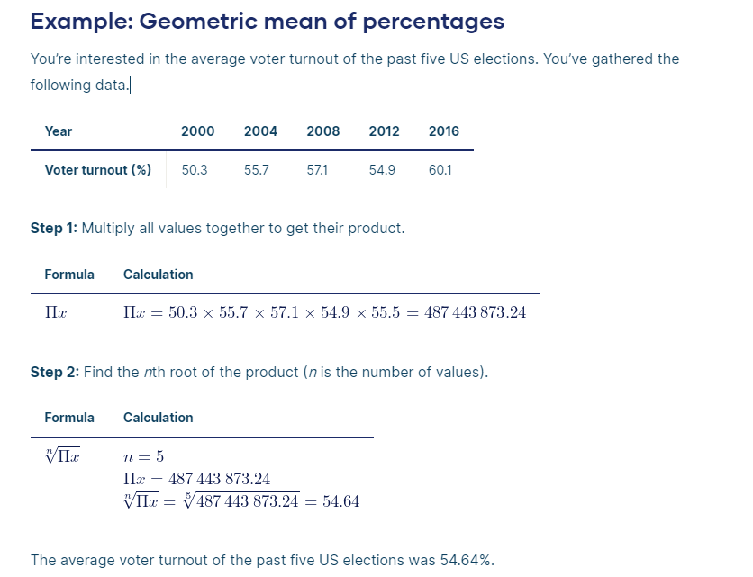
- GEOMEANX(<table>, <expression>) Calculates the geometric mean of a set of expressions evaluated over a table.
- COUNT(<column>) Returns the number of cells in a column that contains non-blank values.
- COUNTX(<table>, <expression>) Counts the number of rows from an expression that evaluates to a non-blank value.
- DIVIDE(<numerator>, <denominator> [,<alternateresult>]) Performs division and returns alternate result or BLANK() on division by 0.
- MIN(<column>) Returns a minimum value of a column.
- MAX(<column>) Returns a maximum value of a column.
- COUNTROWS([<table>]) Counts the number of rows in a table.
- DISTINCT(<column>) Find Unique Data
Another important consideration at this point is that DISTINCT() does not count the blank value
Table = DISTINCT(Fact_Sales[Billno])
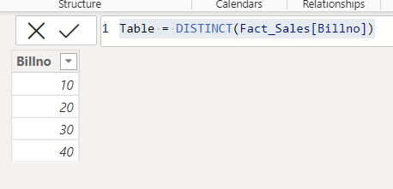
- DISTINCTCOUNT(<column>) Counts the number of distinct values in a column.
- VALUES(<TableNameOrColumnName>) : counts the Distinct products and shows the results based on the incoming filter context.
VALUES() counts the blank value

- RANKX(<table>, <expression>[, <value>[, <order>[, <ties>]]]) Returns the ranking of a number in a list of numbers for each row in the table argument.
Column = RANKX(Fact_Sales,Fact_Sales[Qty Sale],,DESC)
Rank = Rankx(Fact_Sales,Fact_Sales[Sales],,DESC,Dense)

Filter Functions
- FILTER(<table>, <filter>) Returns a table that is a subset of another table or expression.
Table 2 = FILTER(Fact_Sales,Fact_Sales[Qty Sale]>10)

- CALCULATE(<expression>,[ <filter1> [, <filter2> [, …]]]) Evaluates an expression in a filter context.
Measure = CALCULATE(SUM(Fact_Sales[Qty Sale]),Fact_Sales[Qty Sale]>5)
Table = CALCULATETABLE(Fact_Sales,Fact_Sales[Qty Sale]>5)

- HASONEVALUE(<columnName>) Returns TRUE when the context for columnName has been filtered down to one distinct value only. Otherwise, it is FALSE.
Measure = HASONEVALUE (Fact_Sales[Qty Sale]))

- ALLNOBLANKROW(<table> | <column>[, <column>[, <column>[,…]]]) Returns all the Non Blank rows in a table, or all the values in a column, ignoring any filters that might have been applied.
- Table 2 = ALLNOBLANKROW(Fact_Sales[Qty Sale],Fact_Sales[Billno])

- ALL([<table> | <column>[, <column>[, <column>[,…]]]]) Returns all the rows in a table, or all the values in a column, ignoring any filters that might have been applied.
When you use the ALL function in Power BI, it returns the table or column with all filters removed. This means you get a clear and unfiltered view of your data, allowing you to perform calculations and analysis without any filter constraints.
Table 2 = ALL(Fact_Sales[Qty Sale],Fact_Sales[Billno])

- ALLEXCEPT(<table>, <column>[, <column>[,..]]) Returns all the rows in a table except for those rows that are affected by the specified column filters.
Table 2 = ALLEXCEPT(Fact_Sales,Fact_Sales[Qty Sale],Fact_Sales[Billno])

- REMOVEFILTERS([<table> | <column>][, <column>[, <column>[,…]]]]) Clear all filters from designated tables or columns.
Total Sales All Products =CALCULATE ( SUM ( Sales[SalesAmount] ),REMOVEFILTERS ( Products[ProductName] ))
Logical Functions
- IF(<logical_test>, <value_if_true>[, <value_if_false>]) Checks a condition, and returns a certain value depending on whether it is true or false.
test1 = IF(Fact_Sales[Qty Sale]>10,"Good","Poor")

- AND(<logical 1>, <logical 2>) Checks whether both arguments are TRUE, and returns TRUE if both arguments are TRUE. Otherwise, it returns FALSE.
Measure1 = AND([Total Amount]>300000,[Total Amount]<1000000)
test1 = IF(AND(Fact_Sales[Qty Sale]>=5,Fact_Sales[Qty Sale]<=100) ,"Good","Poor")
OR
test1 = IF(Fact_Sales[Qty Sale]>=5 && Fact_Sales[Qty Sale]<=100 ,"Good","Poor")
Ratings = IF(AND(Fact_orders[Quantity]>=0,Fact_orders[Quantity]<=30),"poor",IF(and(Fact_orders[Quantity]>30,Fact_orders[Quantity]<=60),"average",IF(AND(Fact_orders[Quantity]>60,Fact_orders[Quantity]<=100),"Good","Excellent")))

- OR(<logical 1>, <logical 2>) Checks whether one of the arguments is TRUE to return TRUE. The function returns FALSE if both arguments are FALSE.

- NOT(<logical>) Changes TRUE to FALSE and vice versa.
Measure1 = NOT(AND([Total Amount]>300000,[Total Amount]<1000000))

- SWITCH(<expression>, <value>, <result>[, <value>, <result>]…[, <else>]) Evaluates an expression against a list of values and returns one of possible results
test1 = SWITCH(Fact_Sales[CustomerId],1000,"P", 2000,"R","N")
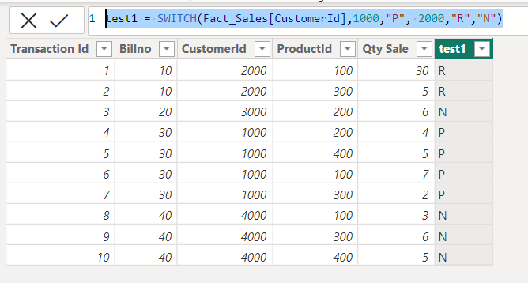
- IFERROR(<value>, <value_if_error>) Returns value_if_error if the first expression is an error and the value of the expression itself otherwise.
Date & Time Functions
- CALENDAR(<start_date>, <end_date>) Returns a table with a single column named "Date" that contains a contiguous set of dates.
Table = CALENDAR("2024-4-4","2024-6-1")

- DATE(<year>, <month>, <day>) Returns the specified date in datetime format.
- DATEDIFF(<date_1>, <date_2>, <interval>) Returns the number of units between two dates as defined in <interval>.
Column = DATEDIFF(Dim_Bill[Billdate],TODAY(),DAY)
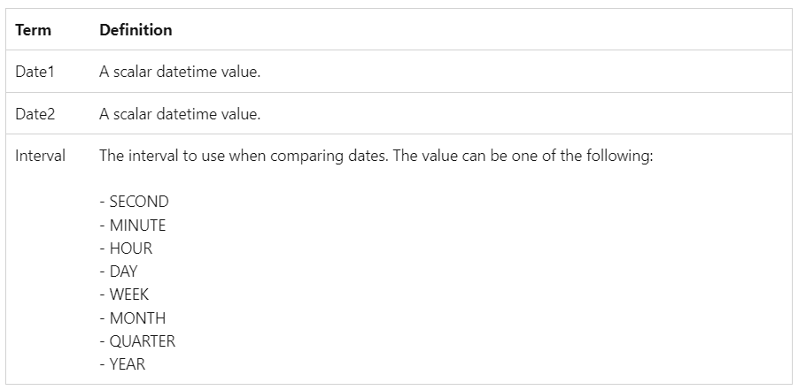
- DATEVALUE(<date_text>) Converts a date in text to a date in datetime format.
- DAY(<date>) Returns a number from 1 to 31 representing the day of the month.
- WEEKNUM(<date>) Returns weeknumber in the year.
Column = WEEKNUM(Dim_Bill[Billdate])

- MONTH(<date>) Returns a number from 1 to 12 representing a month.
YEAR (<date>) Returns YEAR
- QUARTER(<date>) Returns a number from 1 to 4 representing a quarter.
- WEEKDAY(<date>) Returns WEEKDAY
Time Intelligence Functions
- DATEADD(<dates>, <number_of_intervals>, <interval>) Moves a date by a specific interval.
- • Positive → moves forward in time
- • Negative → moves backward in time

Table = DATEADD(SalesData[DateSale],-2,DAY)
Measure = CALCULATE(SUM(SalesData[QtySold]),DATEADD(SalesData[DateSale],2,DAY))
SalesPreviousYear= CALCULATE(SUM(Sales[SalesAmount]),DATEADD('Date'[Date],-1,YEAR)

- DATESBETWEEN(<dates>, <date_1>, <date_2>) Returns the dates between specified dates.
Table = DATESBETWEEN(SalesData[DateSale],DATE(2000,1,1),DATE(2000,12,1))
Measure = CALCULATE(SUM(SalesData[QtySold]),DATESBETWEEN(SalesData[DateSale],DATE(2000,1,1),DATE(2000,12,1)))

- TOTALYTD(<expression>, <dates>[, <filter>][, <year_end_date>]) The TOTALYTD() function in Power BI computes the total of a measure from the beginning of the year to the current selected date. Evaluates the year-to-date value of the expression in the current context.
Measure = TOTALYTD(SUM(Dim_Bill[Billno]),Dim_Bill[Billdate])

TOTALMTD()
The TOTALMTD() function in Power BI calculates the total of a measure from the beginning of the month to the current selected date. This function is useful when analysing month-to-date performance or when creating month-to-date comparisons.
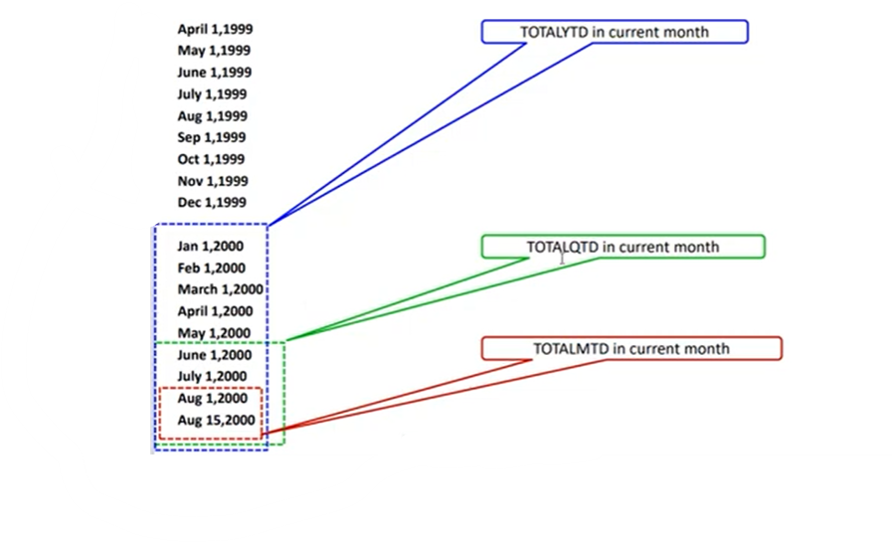
- TOTALQTD()
The TOTALQTD() function in Power BI enables users to calculate the total of a measure from the beginning of the quarter to the current selected date. This function is valuable when analysing quarter-to-date performance or creating quarter-to-date comparisons.

- SAMEPERIODLASTYEAR(<dates>) Returns a table that contains a column of dates shifted one year back in time.
totalsaleyear = CALCULATE(SUM(SalesData[QtySold]),SAMEPERIODLASTYEAR(SalesData[DateSale]))
table= CALCULATETABLE (
SAMEPERIODLASTYEAR ( 'Date'[Date] ),
'Date'[Date] >= StartDate &&
'Date'[Date] <= EndDate
)

- STARTOFMONTH(<dates>) // ENDOFMONTH(<dates>) Returns the start // end of the month.
totalsaleyear = CALCULATE(SUM(SalesData[QtySold]),ENDOFMONTH(SalesData[DateSale]))

- STARTOFQUARTER(<dates>) // ENDOFQUARTER(<dates>) Returns the start // end of the quarter.
- STARTOFYEAR(<dates>) // ENDOFYEAR(<dates>) Returns the start // end of the quarter.

Relationship Functions
- CROSSFILTER(<left_column>, <right_column>, <crossfiltertype>) Specifies the cross-filtering direction to be used in a calculation.
MeasureSale = CALCULATE(SUM(Fact_Sales[Qty Sale]),CROSSFILTER(Fact_Sales[ProductId],Dim_Product[Product Id],OneWay))

MeasureSale = CALCULATE(SUMX(Fact_Sales,Fact_Sales[Qty Sale]*RELATED(Dim_Product[Product Rate])),CROSSFILTER(Fact_Sales[ProductId],Dim_Product[Product Id],Both))

• If you place this measure in a visual where you slice by Product Name, you’ll see correct sales results.
• But if you try to slice by Sales attributes (like Sales Region) to filter Products, it won’t filter Products back because we forced it to one-way filtering only.

- RELATED(<column>) Returns a related value from another table.
- CALCULATETABLE(<table expression>, <filter1>, <filter2>, …)
CALCULATETABLE(Products,Products[SupplierID]==4)

- The CALCULATETABLE() function is like the CALCULATE() function, but it is used to change the filter context of an entire table rather than a single expression. It takes a table expression as its first argument, followed by one or more filter expressions.
MeasureSale = SUMX(
CALCULATETABLE(Fact_Sales, Fact_Sales[Billno]==10),
Fact_Sales[Qty Sale]*RELATED(Dim_Product[Product Rate]))

Table Manipulation Functions
- SUMMARIZE(<table>, <groupBy_columnName>[, <groupBy_columnName>]…[, <name>, <expression>]…) Returns a summary table for the requested totals over a set of groups.
Table = SUMMARIZE(Fact_Sales,Dim_Product[Product Name],Dim_Product[Product Rate],"Total Sale",SUM(Fact_Sales[Qty Sale]))

- DISTINCT(<table>) Returns a table by removing duplicate rows from another table or expression.
- ADDCOLUMNS(<table>, <name>, <expression>[, <name>, <expression>]…) Adds calculated columns to the given table or table expression.
Table = ADDCOLUMNS(Fact_Sales,"Product Rate",RELATED((Dim_Product[Product Rate])))

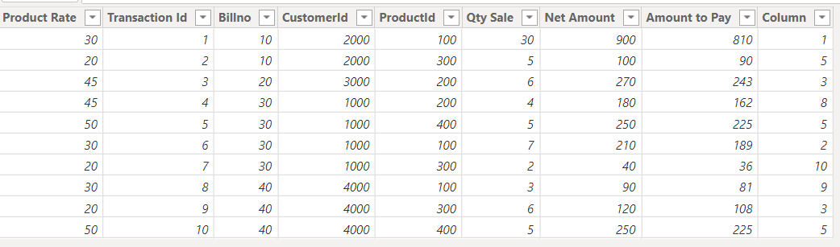

- SELECTCOLUMNS(<table>, <name>, <expression>[, <name>, <expression>]…) Selects calculated columns from the given table or table expression.
Table = SELECTCOLUMNS(Fact_Sales,"Qty Sale",Fact_Sales[Qty Sale],"Product Rate",RELATED(Dim_Product[Product Rate]))

- GROUPBY(<table> [, <groupBy_columnName>[, [<column_name>] [<expression>]]…) Create a summary of the input table grouped by specific columns.
Table = GROUPBY(Fact_Sales,Fact_Sales[ProductId],"COUNT",COUNTX(CURRENTGROUP (),Fact_Sales[Qty Sale]),"QTY SALE",SUMX(CURRENTGROUP(),Fact_Sales[Qty Sale]))
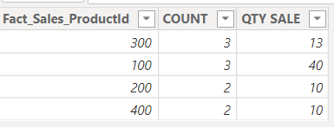
Table = GROUPBY(Fact_Sales,Fact_Sales[ProductId],"Total Sale",SUMX(CURRENTGROUP(),Fact_Sales[Qty Sale]*RELATED(Dim_Product[Product Rate])))

- INTERSECT(<left_table>, <right_table>) Returns the rows of the left-side table that appear in the right-side table.
- CROSSJOIN(<table>, <table>[, <table>]…)
Returns a table that contains the Cartesian product of all rows from all tables in the arguments. The columns in the new table are all the columns in all the argument tables.

- NATURALINNERJOIN(<left_table>, <right_table>) Joins two tables using an inner join.
- NATURALLEFTOUTERJOIN(<left_table>, <right_table>) Joins two tables using a left outer join.
Table = NATURALLEFTOUTERJOIN(Dim_Product,Fact_Sales)
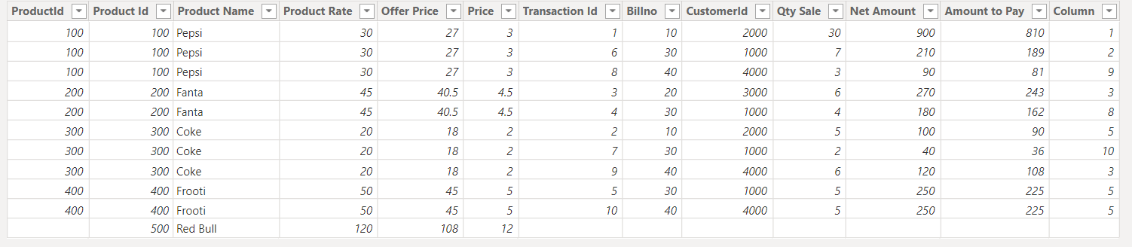

- UNION(<table>, <table>[, <table> [,…]]) Returns the union of tables with matching columns.
- TOPN(<N_Value>, <Table>, <OrderBy_Expression>, [<Order>[, <OrderBy_Expression>, [<Order>]]…])
Returns the top N rows of the specified table.
Table 2 = TOPN(2,Dim_Bill,Dim_Bill[Billno],DESC)

Text Functions
- EXACT(<text_1>, <text_2>) Checks if two strings are identical (EXACT() is case sensitive).
- FIND(<text_tofind>, <in_text>,startposition,notfindvalue) Returns the starting position a text within another text (FIND() is case sensitive).
Column = Find("mul",Dim_Product[ProductName],1,BLANK())

- FORMAT(<value>, <format>) Converts a value to a text in the specified number format.
- LEFT(<text>, <num_chars>) Returns the number of characters from the start of a string.
- RIGHT(<text>, <num_chars>) Returns the number of characters from the end of a string.
- LEN(<text>) Returns the number of characters in a string of text.
- LOWER(<text>) Converts all letters in a string to lowercase.
- UPPER(<text>) Converts all letters in a string to uppercase.
- TRIM(<text>) Remove all spaces from a text string.
- CONCATENATE(<text_1>, <text_2>) Joins two strings together into one string.
- SUBSTITUTE(<text>, <old_text>, <new_text>, <instance_num>) Replaces existing text with new text in a string.
- REPLACE(<old_text>, <start_posotion>, <num_chars>, <new_text>) Replaces part of a string with a new string.
Predefine Formats
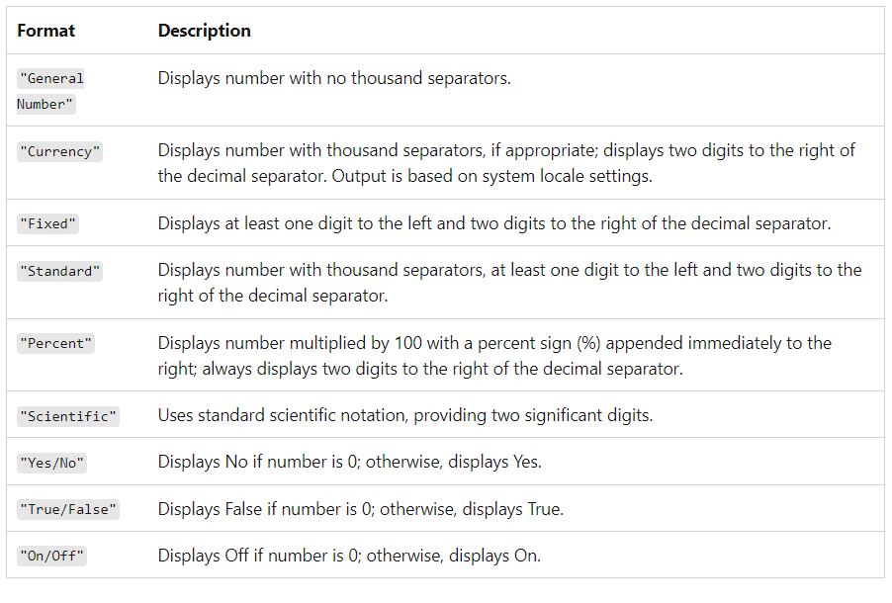

Custom Numeric Format
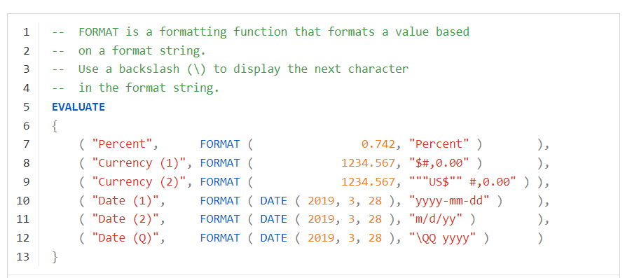
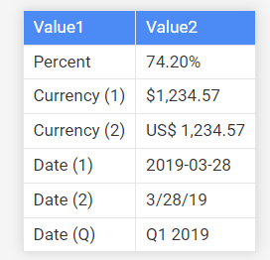

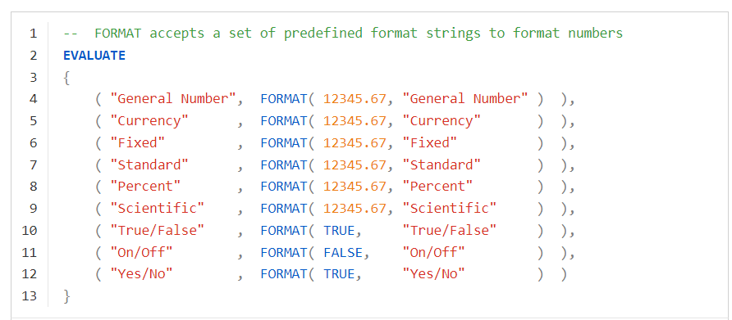
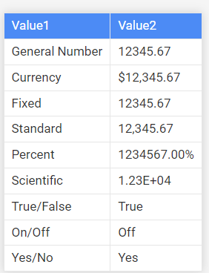

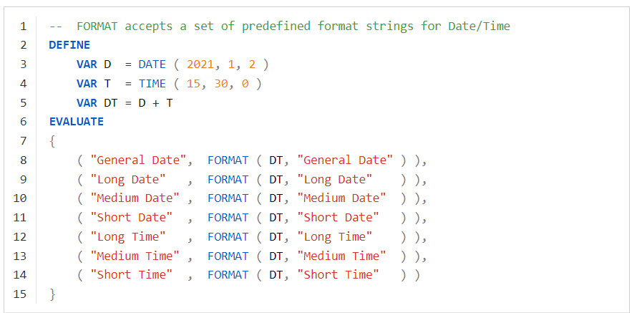
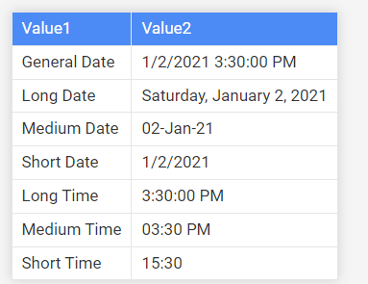

Formats
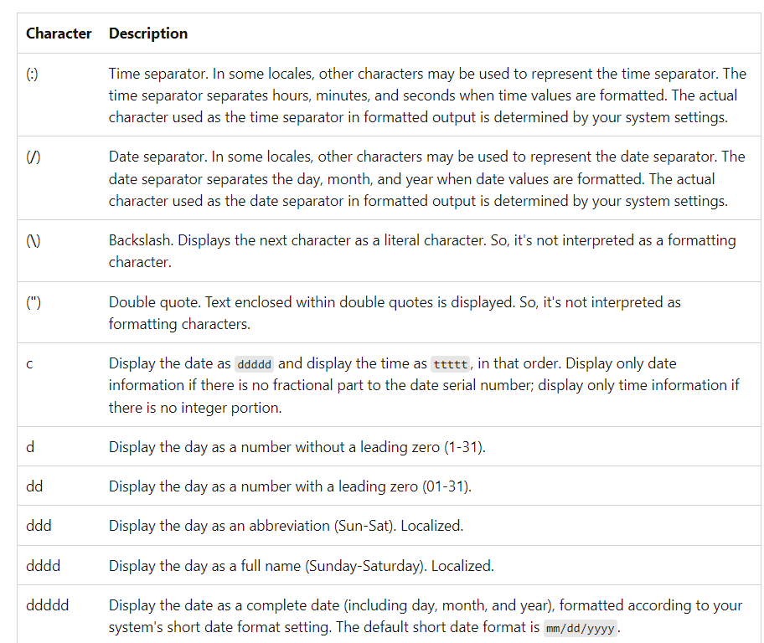

1. Time separator (:)
Used to separate hours, minutes, seconds.
FORMAT(NOW(), "hh:mm:ss")
// Example result: 09:45:22

2. Date separator (/)
Used to separate day, month, year.
FORMAT(TODAY(), "dd/mm/yyyy")
// Example result: 17/08/2025

3. Backslash (\)
Escapes the next character → prints it literally.
FORMAT(TODAY(), "dd \of mmmm, yyyy")
// Example result: 17 of August, 2025

4. Double quote (")
Anything inside quotes is printed literally.
FORMAT(TODAY(), "dd mmmm yyyy ""Report Date""")
// Example result: 17 August 2025 Report Date

5. c
Displays both date and time.
FORMAT(NOW(), "c")
// Example result: 17-08-2025 09:45:22

6. d
Day number (no leading zero).
FORMAT(TODAY(), "d")
// Example result: 17

7. dd
Day number with leading zero.
FORMAT(TODAY(), "dd")
// Example result: 17 (or 05 if day = 5)

8. ddd
Day abbreviation.
FORMAT(TODAY(), "ddd")
// Example result: Sun

9. dddd
Full weekday name.
FORMAT(TODAY(), "dddd")
// Example result: Sunday

10. ddddd
Short date format (depends on system setting, often MM/DD/YYYY).
FORMAT(TODAY(), "ddddd")
// Example result: 8/17/2025 (US system)

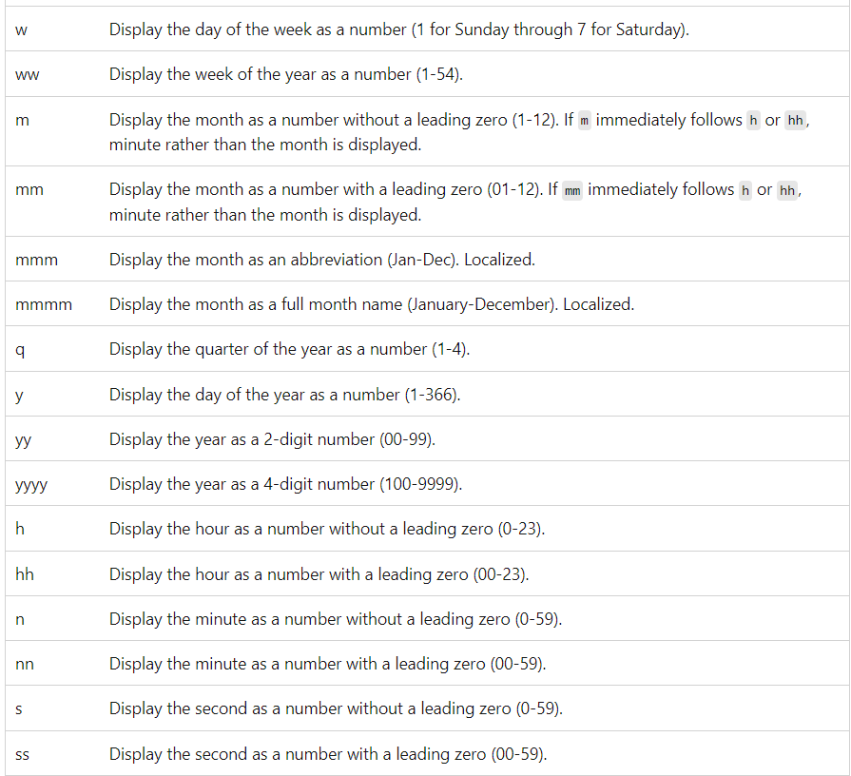1. Day & Week
- w → Day of week as number (1=Sunday, 7=Saturday)
- FORMAT(TODAY(), "w") // Example: 1 (if Sunday)
- ww → Week of year (1–54)
- FORMAT(TODAY(), "ww") // Example: 34

2. Month
- m → Month as number (no leading zero)
- FORMAT(TODAY(), "m") // Example: 8 (for August)
- mm → Month as number (with leading zero)
- FORMAT(TODAY(), "mm") // Example: 08
- mmm → Abbreviated month
- FORMAT(TODAY(), "mmm") // Example: Aug
- mmmm → Full month name
- FORMAT(TODAY(), "mmmm") // Example: August

3. Quarter
- q → Quarter of year (1–4)
- FORMAT(TODAY(), "q") // Example: 3

4. Day of Year
- y → Day number of year (1–366)
- FORMAT(TODAY(), "y") // Example: 230

5. Year
- yy → 2-digit year
- FORMAT(TODAY(), "yy") // Example: 25
- yyyy → 4-digit year
- FORMAT(TODAY(), "yyyy") // Example: 2025

6. Hour
- h → Hour (0–23, no leading zero)
- FORMAT(NOW(), "h") // Example: 9
- hh → Hour (00–23, with leading zero)
- FORMAT(NOW(), "hh") // Example: 09

7. Minute
- n → Minute (no leading zero)
- FORMAT(NOW(), "n") // Example: 5
- nn → Minute (with leading zero)
- FORMAT(NOW(), "nn") // Example: 05

8. Second
- s → Second (no leading zero)
- FORMAT(NOW(), "s") // Example: 7
- ss → Second (with leading zero)
- FORMAT(NOW(), "ss") // Example: 07

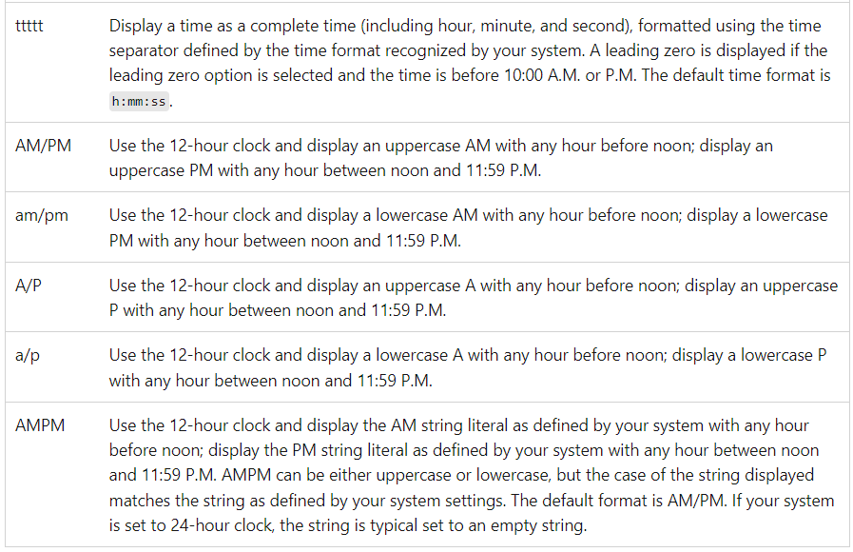

1. ttttt
- Displays full time (hour:minute:second) in system format.
FORMAT(NOW(), "ttttt")
// Example: 10:25:34

2. AM/PM
- 12-hour format with uppercase AM or PM.
FORMAT(NOW(), "hh:nn:ss AM/PM")
// Example: 10:25:34 AM

3. am/pm
- 12-hour format with lowercase am or pm.
FORMAT(NOW(), "hh:nn am/pm")
// Example: 10:25 am

4. A/P
- Shows only A or P (uppercase).
FORMAT(NOW(), "hh:nn A/P")
// Example: 10:25 A

5. a/p
- Shows only a or p (lowercase).
FORMAT(NOW(), "hh:nn a/p")
// Example: 10:25 a

6. AMPM
- Uses system-defined string for AM/PM (could be localized or custom).
FORMAT(NOW(), "hh:nn:ss AMPM")
// Example (US system): 10:25:34 AM
// Example (other locale): could vary

Custom date/time format examples
The following examples use the date/time Thursday, June 25, 2020, at 1:23:45 PM. Germany (de-DE) uses a 24-hour system. There's no equivalent of AM/PM.

Format | Result (en-US) | Result (de-DE)
"c" | 06/25/2020 13:23:45 | 25.06.2020 13:23:45
"d" | 25 | 25
"dd" | 25 | 25
"ddd" | Thu | Do
"dddd" | Thursday | Donnerstag
"ddddd" | 06/25/2020 | 25.06.2020
"dddddd" | Thursday, June 25, 2020 | Donnerstag, 25. Juni 2020
"w" | 5 | 5
"ww" | 26 | 26
"m" | 6 | 6
"mm" | 06 | 06
"mmm" | Jun | Jun
"mmmm" | June | Juni
"q" | 2 | 2
"y" | 177 | 177
"yy" | 20 | 20
"yyyy" | 2020 | 2020
"""Year"" yyyy" | Year 2020 | Year 2020
"yyyy \Qq" | 2020 Q2 | 2020 Q2
"dd/mm/yyyy" | 25/06/2020 | 25.06.2020
"mm/dd/yyyy" | 06/25/2020 | 06.25.2020
"h:nn:ss" | 13:23:45 | 13:23:45
"h:nn:ss AMPM" | 1:23:45 PM | 1:23:45
"hh:nn:ss" | 13:23:45 | 13:23:45
"hh:nn:ss AMPM" | 01:23:45 PM | 01:23:45
"ttttt" | 13:23:45 | 13:23:45
"ttttt AMPM" | 13:23:45 PM | 13:23:45
"mm/dd/yyyy hh:nn:ss AMPM" | 06/25/2020 01:23:45 PM | 6.25.2020 01:23:45

DAX Statements

- VAR(<name> = <expression>) Stores the result of an expression as a named variable. To return the variable, use RETURN after the variable is defined.
Profit Margin =
VAR TotalSales = SUM ( Sales[SalesAmount] )
VAR TotalCost = SUM ( Sales[CostAmount] )
VAR Profit = TotalSales - TotalCost
RETURN
DIVIDE ( Profit, TotalSales )
- COLUMN(<table>[<column>] = <expression>) Stores the result of an expression as a column in a table.
- ORDER BY(<table>[<column>]) Defines the sort order of a column. Every column can be sorted in ascending (ASC) or descending (DESC) way.
DAX Operators
Comparison operators |  | Meaning
= |  | Equal to
= = |  | Strict equal to
> |  | Great than
< |  | Smaller than
> = |  | Greater than or equal to
= < |  | Smaller than or equal to
< > |  | Not equal to
Text operator | Meaning | Example
& | Concatenates text values | Concatenates text values | [City]&", "&[State]

Logical operator | Meaning | Example
&& | AND condition | ([City] = "Bru") && ([Return] = "Yes"))
|| | OR condition | ([City] = "Bru") || ([Return] = "Yes"))
IN {} | OR condition for each row | Product[Color] IN {"Red", "Blue", "Gold"}
High Sales = CALCULATE(
SUM(Sales[SalesAmount]),
Sales[SalesAmount] > 1000 && Sales[Region] = "East"
)

IN Keyword
Example
Table 2 = FILTER(Fact_Sales,Fact_Sales[Rating] in {"Good",”Poor”})

Merging Dax Function
- M=SUMX (FILTER (Orders, Orders[Price] > 1 ), Orders[Quantity] * Orders[Price] )
- M = SUMX(FILTER(Fact_Sales,Fact_Sales[Rating] in {"Good"}),Fact_Sales[QtySale])
- RELATEDTABLE()
M=SUMX(ALL(Fact_Sales),SUMX(RELATEDTABLE(Dim_Product),Fact_Sales[QtySale]*Dim_Product[Rate]))
M=SUMX(ALLSELECTED(Fact_Sales),SUMX(RELATEDTABLE(Dim_Product),Fact_Sales[QtySale]*Dim_Product[Rate]))
M=SUMX(ALLEXCEPT(Fact_Sales),SUMX(RELATEDTABLE(Dim_Product),Fact_Sales[QtySale]*Dim_Product[Rate]))

- M = CALCULATE(SUM(Fact_Sales[QtySale]),FILTER(ALL(Fact_Sales[Rating]),[Rating]=="Good"))

Ignoring Filters
- M = SUMX(ALL(Fact_Sales),Fact_Sales[QtySale]*10)
Or
- M = SUMX(Fact_Sales,Fact_Sales[QtySale]*10)

COUNTROWS()
- mcount = COUNTROWS(DISTINCT(Fact_Sales[Rating]))
- mcount= COUNTROWS(FILTER(Fact_Sales,Fact_Sales[Rating]="Good"))

KEEPFILTERS()

- M = CALCULATE ([NetAmount],KEEPFILTERS ( Fact_Sales[Rating] IN { "GOOD" } ))

Context
  - Filter Context
  - Rows Context

